Association, Composition and Aggregation

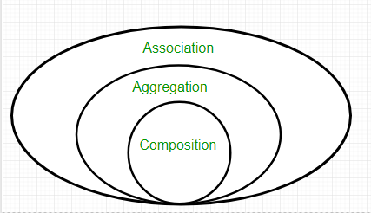

Association is relation between two separate classes which establishes through their Objects. Association can be one-to-one, one-to-many, many-to-one, and many-to-many.  
In Object-Oriented programming, an Object communicates to other Object to use functionality and services provided by that object. **Composition** and **Aggregation** are the two forms of association.